1. **Write the c program to implement single source shortest path technique .**

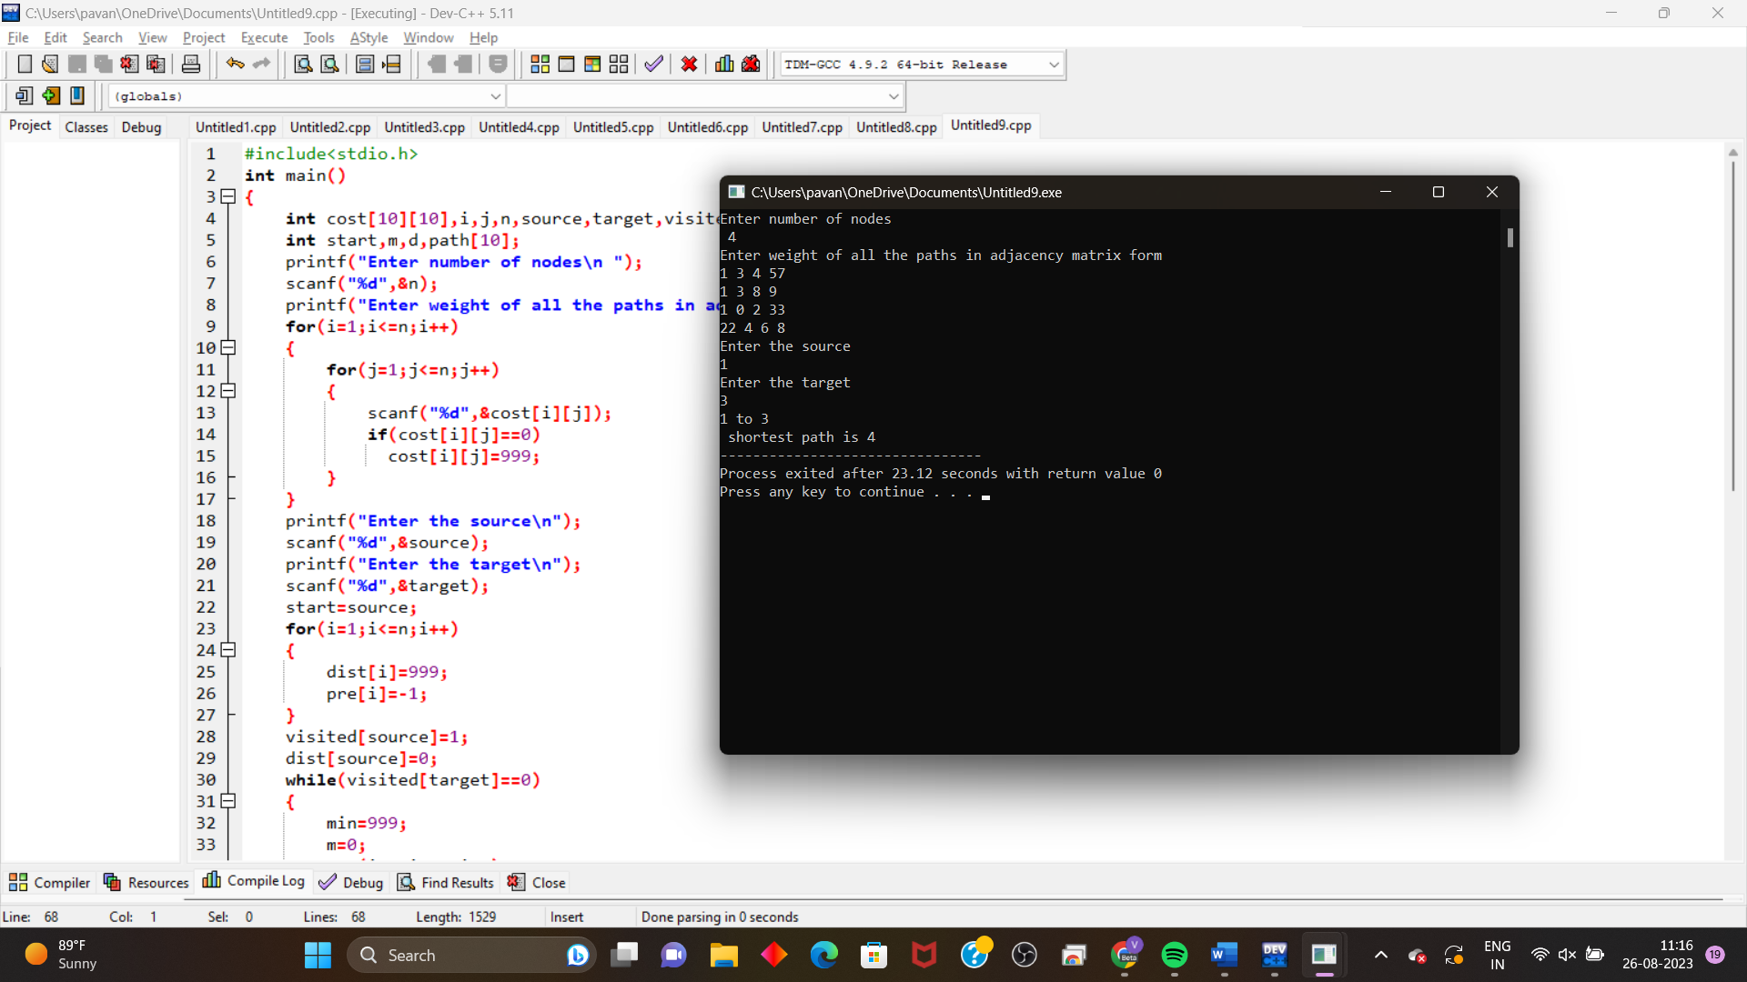

1. **Write the c program to implement minimum spanning tree using Kruskal algorithm.**

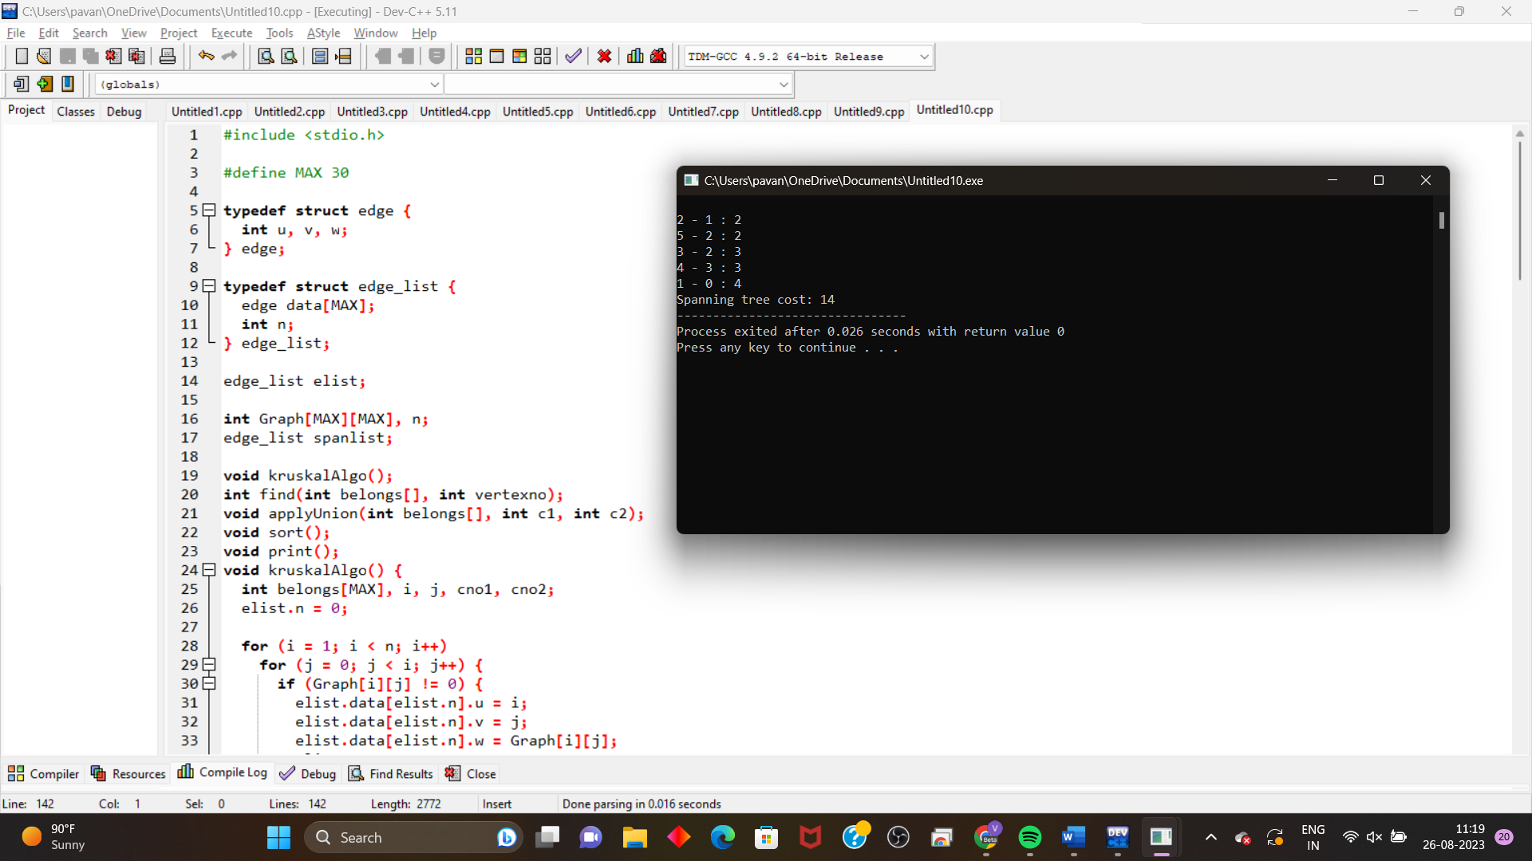

1. **Write the c program to implement BFS graph traversal.**

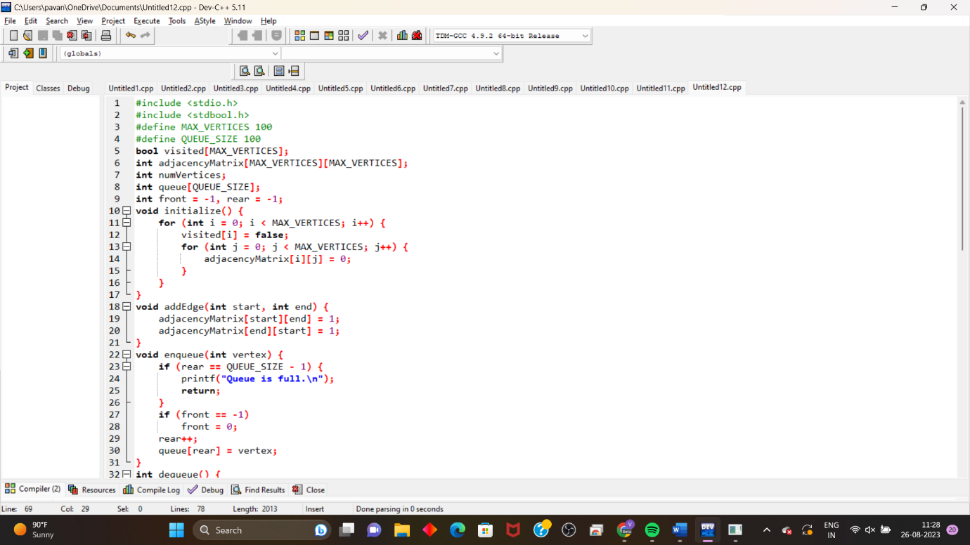

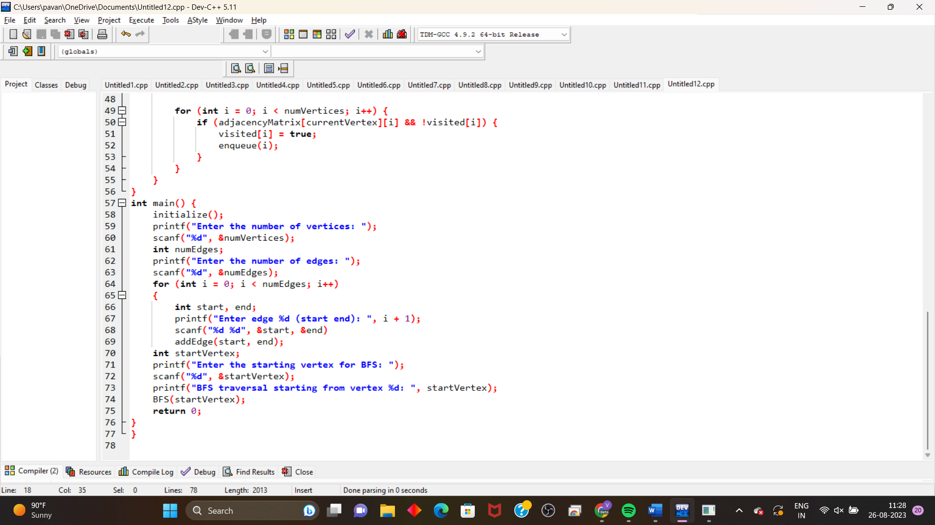

1. **Write the c program to implement depth for search graph traversal.**

